****  **K. E. Thornton**

[**neuroeducation.co**](http://neuroeducation.co)

***9635 Southern Pine Blvd. Ste. 105, Charlotte, NC, 28273-5558***

***Phone: 980-229-4962 Fax: 803-675-0969 Email:*** [***ket@chp-neurotherapy.com***](mailto:ket@chp-neurotherapy.com) ***NC Lic. 4294***

Re: Memory problems, Brain Injury, special education, learning disabilities, Dyslexia, ADD, cognitive problems in children, prison population, IQ, impulsivity

I received the following email from a client recently after her son had engaged in about 40 hours of EEG biofeedback intervention.

“I got a report on my son from his school. Beginning of 4th grade, he was reading at a kindergarten level, now he is reading at a 2nd grade level with 98% accuracy and they predict he will be at 3rd grade level by the end of January! 😊” A very heart-warming email.

All men and women are created equal. Not all brains are created equal. For the past 25 years, I have been working on the problem of how to improve brain function with the use of EEG biofeedback and a patented cognitive activation database. The data reported (Table 1) below reflect my progress (Thornton & Carmody, 2013). I believe we can improve the effectiveness of your interventions by employing the EEG biofeedback approach.

This letter is divided into 9 sections as follows:

Section I Comparison of present intervention models

Section II Prison population – ADD, ADHD, TBI, Substance Abuse, Learning Disabilities

Section III What is the QEEG?

Section IV What are research effects of EEG biofeedback?

Section V The CAR Model - The electrophysiology of the Brain

Section V1 Specific Cognitive effects of the CAR approach.

Section VI1 Automated QEEG Software

Section VIII Conclusions and considerations

Section IX References

The basic logic of the EEG biofeedback approach is that 1) there is an empirical relationship between the QEEG variables and cognition and behavior; 2) we can change the electrophysiological of the brain via operant conditioning (rewarding / inhibiting) of the EEG signal; 3) which will result in positive changes in cognitive ability and behavior, which is critical for success in life; 4) **the approach** **changes ability which precedes any changes in achievement performances**. In other words, we can change how the brain works.

This document will present the evidence supporting the basic logic and reflecting the significantly superior results of the approach to presently employed intervention methods employed.

**Section I – Comparison of present intervention models**

The memory improvement results (with EEG biofeedback) shows significantly better results than the average results of tutoring programs (~.46 Standard Deviations (SD), computer interventions (~ .61 SD) and cognitive rehabilitation programs (~.26 SD). The measure employed is spontaneous free recall, a demanding cognitive task and critical to other cognitive abilities. You can’t solve a problem if you can’t recall the problem.

Table 1



*TBI=Traumatic Brain Injury SLD=Specific Learning Disability SD=Standard Deviation*

*For comparison purposes, 1 SD of weight is 30 lbs.*

In addition, all the groups were performing above their respective normative reference group memory performances, thus “cured” of their memory problems; a statement no other intervention models are able to make. A control group (N=15) showed no improvement over 15 stories administered. In addition, there were significant changes in the values of the QEEG’s communication variables (coherence and phase) averaging a little under 2 SD (N=59) and arousal variable (32-64 Hz). Thus, documented changes in the physical functioning of the brain have been established. Figure 1 compares the EEG approach to other currently employed intervention models. The Coordinated Allocation of Resource Model (CAR) asserts that each cognitive ability is a function of the use of specific resources, which can overlap across different abilities. Effect size (ES) is a measure of the degree of change.

Figure 1

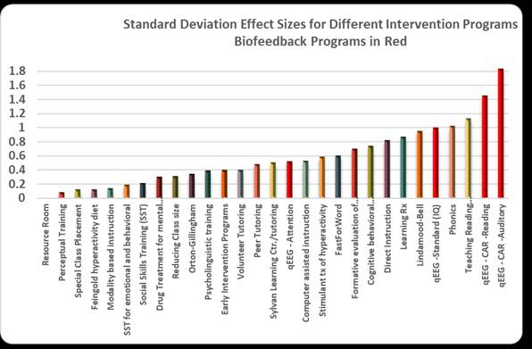

The red bars present the results of different EEG biofeedback programs. Only the last two red bars (CAR) employ very specific EEG intervention protocols which address the dysfunctional areas and connections as revealed in the activation QEEG evaluation. The average # of sessions were 45 or about 23 hours.

The special education interventions offered over the past several decades have not shown the results we need in this area. Part of the problem resides in the fact that there are underlying neurobiological problems driving these problems (Eden & Zeffiro, 1998, Ramus, 2004, Shaywitz, 2004) which aren’t being specifically addressed with commonly used intervention programs. The McCandliss and Noble (2003) review pointed to a problem in the superior temporal gyrus and left occipito-temporal extrastriate visual system in dyslexia. The history of interventions can be conceptualized as “outside” interventions as they characteristically change the environment the child is exposed to with specially designed interventions. These interventions are hoped and thought to be able to change the underlying problem in brain functioning which is resulting in cognitive problems. Thus, tutoring type interventions will focus on strategies, computer interventions and a host of other external stimulation approaches. However, this basic approach has shown to produce similar results no matter what external stimulation is being employed.

For example, Ritchey and Goeke (2006) reviewed 12 Orton-Gillingham (OG) based studies and found mixed results. What Works Clearing House (WWC) reported that the OG did not meet its standards (U.S. Department of Education, Institute of Educational Sciences (IES), 20010a). The Wilson reading system is a derivative of the OG method. The Wilson program is implemented over a 1-3-year period in a 12-step sequence (Wilson & O’Conner, 1995). Wood (2002) reported a .38 SD improvement on the Woodcock Reading Master Test total reading cluster over a 1-year intervention period which included subtests of Word Identification, Word Attack, Passage Comprehension, & Basic Skills. The WWC reviewed 9 studies and concluded that the Wilson Method may have a positive effect on a student’s understanding of alphabetic principles but little effect on fluency and comprehension. The Lindamood-Bell intervention program (2005) reported gains of .60 SD on word reading and .35 SD on sentence/paragraph reading after one year of instruction. WWC reviewed one study using the Lindamood Phonemic sequencing and found possible benefits on alphabetic principles and reading fluency and possible negative effects on writing skills. Bentum & Aaron (2003) assessed the effect of resource room reading instruction after 3 years (N=230) and 6 years (N=64) of instruction. Pre- and post- test reading achievement and IQ scores were obtained for both groups. The results indicated no improvement on word recognition or reading comprehension and a decrease in spelling scores. The 6 year group demonstrated a decrease on verbal IQ measures. Additionally, the Fast ForWord program has not proven to be effective for reading improvement (Strong, Torgerson, Torgerson & Hume (2011). A recent review of reading programs is available on the internet at <https://www.evidenceforessa.org/programs/reading/elementary>. The review covered 66 programs with an average effect size of .27 SD. (range 0-.87). Reading rescue (SD=.89) costs $10-$15 K a year for about 95 30-minute sessions. Early steps (.86 SD) requires 190 30-minute sessions. WhatWorks (<https://ies.ed.gov/ncee/wwc/>) reports similar results in their analysis. The Car EEG intervention results reported are for 45 sessions. Figure 2 shows a comparison of the standard deviation effect size across the Reading Rescue, Early Steps and the EEG bio (CAR) intervention models.

Figure 2 – Average Standard Deviation Effect Per session per model

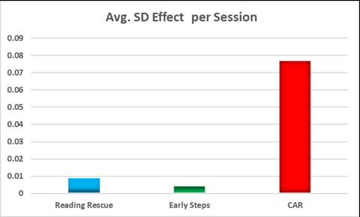

The IEP guided intervention model is employed in school settings. Forness (2001) examined the effects of the components of “special” interventions (unique and different methods that would not be routinely used in general education) including psycholinguistic training, social skills training, modality instructions, perceptual training; special “education” (adapting and modifying instruction) including **mnemonic strategies, reading comprehension strategies, direct instruction, formative evaluations, computer assisted instructed, peer tutoring, word recognition strategies**; “related” services because they are dependent either on treatments not directly delivered by teachers or on treatments in which considerable consultation from other professionals (e.g., school psychologists or behavioral therapists) is often necessary in individual cases for the teacher to implement them in the classroom – behavior modification, cognitive behavior modification, psychotherapy, simulant and psychotropic medication. **The “special” education interventions produce an ES of .20. The special “education” intervention emphasizes effective and validated instructional techniques. The seven interventions in this group produced an ES of .84. “Related” services occupy a midway point of .53.** The IEP intervention presumable relies upon a combination of “special” intervention and special “education” approaches. The approach can also incorporate speech language and occupational interventions, among others.

The problem is not in the individuals employing these methods, but the methods are not an effective way to approach the problem. The pattern across these studies and many more is that these “outside” approaches do have some effect, but are insufficient to fix the basic problem in brain functioning, which is an “inside” problem. The “inside” approach is characterized by the EEG biofeedback approach, which attempts to change the underlying electrophysiological signals.

A review of this area is available at <http://neuroeducation.co/no-child-left-behind/> as well as a compilation of articles addressing specific QEEG correlates of a number of cognitive skills across two age groups (child, adult) at <http://neuroeducation.co/how-the-cognitive-brain-works-the-quantitative-eeg-and-cognition/>

Figure 3 shows a comparison with different approaches for the head injured subject.

Figure 3

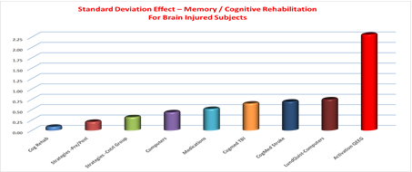

**Achievement vs Ability**

The treatment improved his ability level, which was followed by improvements on achievement measures. There were no interventions on achievement skills. (Figure 4). The figure below shows the improvement in one child over a period of 3 years on nationally standardized testing.

Figure 4

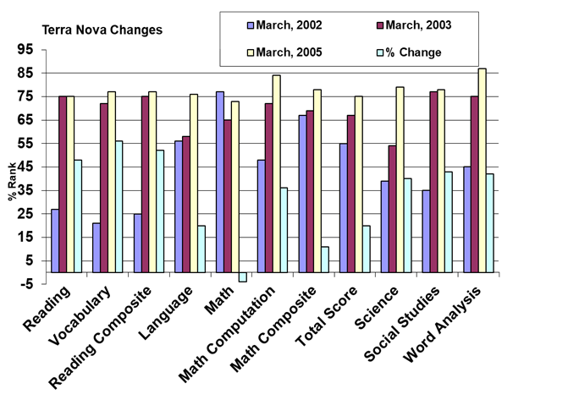

**Section II -Prison population – ADD, ADHD, TBI, Substance Abuse, Learning Disabilities**

“15 studies from peer-reviewed journals show that 21-45% of prisoners have ADHD; ADHD subjects are 4 to 9 times more likely to commit crimes and go to jail; 46% of female prisoners in Rhode Island met criteria for childhood ADHD; A Swedish study showed 40% of adult male longer-term prison inmates had ADHD; The overall prevalence of ADHD in young male prisoners according to DSM-IV was 45%; For violent offending, ADHD symptoms were the strongest predictor followed by alcohol dependence.”

<http://adultaddstrengths.com/2011/01/12/adhd-and-crime-ignore-now-jail-later-15-clinical-studies/>

“About 8.5 percent of U.S. non-incarcerated adults have a history of traumatic brain injury (TBI), and about 2 percent of the greater population is currently suffering from some sort of disability because of their injury. In prisons, however, approximately 60 percent of adults have had at least one TBI. In a recent South Carolina survey of 636 prisoners, some 65 percent of males and 73 percent of females reported having sustained TBIs at some point in their lives”

<https://www.scientificamerican.com/article/traumatic-brain-injury-prison/>

“Slaughter, Fann, and Ehde (2003) conducted standardized interviews with 69 randomly selected inmates in a county jail in Seattle, Washington. 87% percent of the subjects reported having had a TBI during their lifetime: 36.2% reported having had a TBI in the prior year.; It was noted that those with a more recent injury presented with a higher prevalence of anger, aggression, cognitive problems, and psychiatric problems at the time of the evaluation than those who had been injured previously. (Slaughter et al., 2003)

<http://www.brainline.org/content/2009/05/traumatic-brain-injury-in-prisons-a-review_pageall.html>

“Up to 50% of the prison population has some type of learning disability; Up to 60% of adolescents in treatment for substance abuse have learning disabilities; 31% of adolescents with learning disabilities will be arrested 3-5 years out of high school; 50% of juvenile delinquents tested were found to have undetected learning disabilities; 2/3 of all prisoners are below seventh grade in numeracy; 4/5 are below seventh grade in writing”<http://odpc.ucsf.edu/sites/odpc.ucsf.edu/files/pdf_docs/REVISEDforensicpsychSQ.pdf> Washington Summit on Learning Disabilities, 1994

This prison population analysis indicates that the special education child is particularly vulnerable to future problems. Many of these children also end up on the disability roles. All of these conditions have been shown to be responsive to EEG biofeedback interventions. I have recently published an article documenting that the effects of the treatment cannot be considered a placebo effect (Thornton, 2018).

The state that currently spends the least on youth incarceration is Louisiana ($46,662 a year per offender), and the state that spends the most is New York ($352,663 a year per offender).

<http://www.justicepolicy.org/news/8570>

In adult correctional facilities, 28-43% of inmates need special education (vs. 5% in normal population) 82% of prison inmates in U.S. are dropouts In New York City, average cost of incarcerating a youth is $55,300 a year. (Winter, 1997) 30% of children with Learning Disability have been arrested within 3-5 years after High School Graduation 58% of children with Emotional disability arrested 3-5 yrs. After graduation, 6% of normal students arrested 1x before graduation.

Arns et al. (2014) meta-analysis incorporated 15 studies on neurofeedback from 2009 and found large effect sizes for inattention (.81 SD) and medium effects sizes (.55 SD) for hyperactivity and impulsivity. The effects did not disappear with time, and a tendency for further improvement across time for hyper-activity/impulsivity. Burkett et al. (2005) reported on 270 male addicts who received 30 EEG biofeedback sessions. Within the addict group, 53.2% reported no alcohol or drug use 12 months after biofeedback, and 23.4% used drugs or alcohol only one to three times after their stay. This was a substantial improvement from the expected 30% or less expected recovery in this group. Self-report depression scores dropped by 50% and self-report anxiety scores by 66%. Thornton (2013) reported on the memory improvements in the brain injured, normal and learning-disabled groups indicated above normative values at the end of the treatment period.

It is important to note that jobs are not threatened by this technology, it merely requires about 5 days of retraining. The retraining will result in better outcomes and greater results from standard tutoring interventions. Start-up costs for one unit and training is $12,000 to $15,000. A small research grant could obtain the financial requirement. I can help write the grant should you choose to pursue this approach. The cost of a 40-session program, after initial equipment and software costs, is $500. As a clinician and researcher, I can only bring you the research results which I believe will help these children. Much of academic research is in the pursuit of better options and understanding and not implementation. It is generally argued in educational discussions that the earlier you can effectively intervene, the greater the rewards for society and the individual. None of the tutoring interventions have shown decreases in impulsivity.

**Section III - What is the QEEG?**

Figure 5 shows how the sensors are placed on the head.

**Figure 5: The 10-20 system**



The quantitative EEG (QEEG) involves the digitization of the analog EEG signal, a technology developed during the 1990s. There have been thousands of research articles published in this area during the past 3 decades. The QEEG looks at some 2000 variables involved in two areas: arousal and communication across 4 frequencies (delta: 0-4 Hz; theta: 4-8 Hz; alpha: 8-13 Hz; beta1: 13-32 Hz; beta2; 32-64 Hz). The biofeedback approach employs operant conditioning (rewarding/inhibiting) of the EEG signal. Operant conditioning is a heavily researched intervention method. Tutoring involves the same concept as it rewards the student for producing the correct response and discourages the student from an incorrect response. The difference resides in whether we are rewarding/inhibiting verbal or other output from the student or their electrophysiology.

**Section IV – What are research effects of EEG biofeedback?**

Initial EEG biofeedback approaches have focused on the arousal variables (theta – beta microvolts). Four studies showed average gains of 15 points on standard IQ measures (WAIS, WISCR, etc.) (Tansey, 1991; Linden et al., 1996; Thompson & Thompson, 1998); Othmer & Othmer, 1992). Other research has focused on the coherence relationships. For example, Coben, Wright, Decker and Morgan (2015) reported average improvements of 1.2-grade levels in reading scores following two channel coherence neurofeedback over the left hemisphere (20 sessions, N=42 learning disabled students). There were no changes in the control group (typical resource room instruction). They employed eyes closed and eyes open data to guide the interventions towards the low coherence connections in the left hemisphere, mostly the occipital-parietal to frontal-temporal regions in the delta, theta and alpha frequencies. Inhibit feedback on the delta-theta amplitudes was also employed. These approaches do not address the brain as a total system, nor looks at the brain as it responds to specific cognitive tasks, nor examines the 32-64 Hz frequency range, nor looks at the variables involved in effective performance for specific tasks. Our approach examines all of these issues.

**Section V – The CAR Model The electrophysiology of the Brain**

The research I have conducted has demonstrated that the Coordinated Allocation of Resource Model (CAR) is an appropriate way to view cognitive skills as it states that each cognitive skill employs a different set of resources (albeit overlapping in some cases) to effectively accomplish a task. We need to address the special education problem from this point of view. We cannot assume that tutoring approach A or B will selectively engage the appropriate resources, as we are not even sure what A or B is addressing from an electrophysiological point of view. We have effectively addressed both arousal and communication variables (Thornton, 2006; Thornton, K. & Carmody, D., 2013).

There are many other published research reports attesting to the positive effects of EEG biofeedback, which are too numerous to mention in this communication.

The problem the field faces is: What signal do we need to reward and what signal do we need to inhibit and regarding what cognitive skill? The power of the CAR approach is that it defines specifically the variables that are involved in cognitive performance and identifies the specific weaknesses in a subject. Most approaches in this field focus on inhibiting theta microvolts and increasing SMR beta microvolts along the sensori-motor strip. These variables are important but are not are the critical variables for cognitive improvements. For example, Figure 6 shows the coherence alpha values (color-coded – blue low – red /yellow high) for different subjects during an auditory memory task. The subject on the right would have a higher auditory memory score. The colored bar below the figure represents the standard deviation value in colors.

Figure 6 – Auditory Memory example T3 Coherence alpha

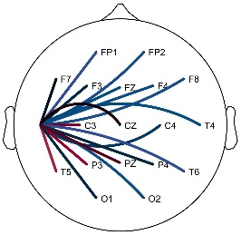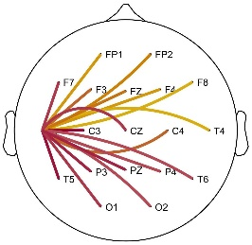

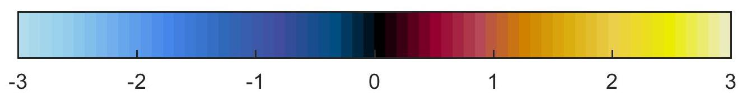

In the second example, we are looking at the ability to perform multiplication tables in a group of children (Figure 7). In this example, the better performing child had higher coherence and phase communication patterns in the frontal lobes in the alpha and beta frequencies. There were other variables involved, but are not presented in the interest of simplicity. Thus, the child who performed better was making the calculations in the frontal lobe and employing communication patterns in specific frequencies.

Figure 7 – Child’s multiplication ability indicated in frontal lobe connection patterns

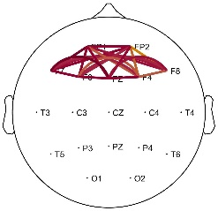



The QEEG can also address diagnostic questions, such as a head injury. Figure 8 presents the variables that are deficient in the head-injured subject. These mainly involve the communication patterns (coherence and phase) in the gamma frequency (32-64 Hz). In this figure, blue indicates below normal values, and red indicates above normative values.

Figure 8



CB2= Coherence (SCC) beta2 (32-64 Hz): PB2=Phase beta2; RPB2=Relative Power Beta2

Using these variables we have been able to obtain a 99% discriminant accuracy rate in differentiating brain injured from normal subjects (Thornton, 2014). There is no other published research that can match these results. The Veteran Administration is working on submitting a research proposal to follow up on this research.

**Identifying Specific Electrophysiological Deviations**

The value of the approach resides in its ability to define very specifically what are the deficits in electrophysiological functioning which can then be directly addressed with the EEG biofeedback approach.

The approach has provided us with an improved QEEG microscope to understand brain functioning. With this technology, we can focus on specific areas of dysfunction for rehab purposes. Figure 9 below represent frontal lobe dysfunction and F7 low connection values in a patient. The view is from the top of the head looking down with the left ear on the left side and the nose on top. The connection values are expressed in standard deviation (SD) values follow the color coding presented below, with blue representing below average and red/yellow above average.

Figure 9

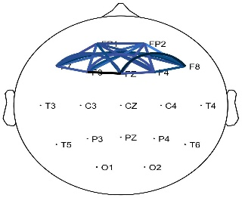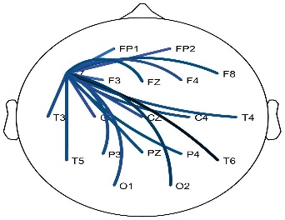



Table 2 shows a spreadsheet analysis of a patient who is demonstrating problems in frontal lobe beta2 (32-64 Hertz) connection patterns. The -1.01 (frontal CPU) value is the average SD value within the frontal lobes. The -.96 value on the bottom row represents the average SD value of the connection patterns emanating from the T3 location (left temporal lobe). Thus, this subject has problems in frontal lobe connection patterns and signals coming from the T3 location.

Table 2



It is this level of statistical and technical precision that allows us to obtain the results we have achieved. This approach is significantly different from other currently employed EEG biofeedback models which focus on SMR frequencies (12-18 Hz), don’t examine the gamma frequency (32-64 Hz), don’t examine cognitive activations tasks, and don’t know the relationships between the QEEG variables and cognitive performance.

**Section VI - Specific Cognitive effects of the CAR approach.**

The following figures show the specific effects of employing the CAR model with auditory and reading memory problems, both in terms of standard deviation changes and relationship to normative values. The average # of sessions were 45 (~23 hours). Once the correlates of a cognitive skill are understood, it is relatively straight forward to focus on the deficit functioning variables with the operant conditioning EEG biofeedback approach. A fascinating recent finding from the research is indicating that the primary deficit in the learning-disabled student is a problem in the phase relationships, especially alpha and theta. This deficit can be effectively addressed with EEG biofeedback. The phase value represents the delay of the signal between point A and point B.

**Figure 10 – Standard Deviation (SD)**

TBI=Traumatic Brain Injury Adult SLD=Adult Specific Learning Disability Child SLD=Child Specific Learning Disability

Red line .80 SD effect size – considered a large effect

**Figure 11**

**Figure 12 - % Improvement**

**Figure 13 – Auditory Memory – improvement to above normative values**

**Figure 14 – Reading Memory – improvement to above normative values**

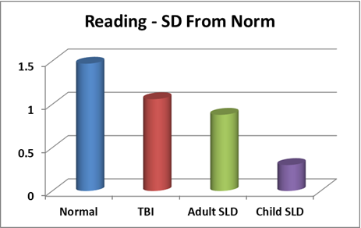

**Specific Changes in QEEG as a result of CAR interventions**

Figure 15 shows the physical changes in the coherence values as a result of the interventions represented in standard deviation units.

Figure 15 – Raw Score and SD changes in coherence values

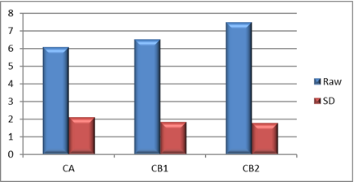

CA=Coherence Alpha; CB1=Coherence Beta1; CB2=Coherence Beta2

Significant results were also obtained for increases in relative power of beta2.

**Section VII - Automated QEEG Software**

We have developed a highly automated cognitive activation QEEG evaluation which assesses 6 cognitive skills (auditory and visual attention, auditory and reading memory, working memory, problem-solving) while the QEEG data is collected. A subject’s response pattern is compared to the normative database on all the variables and, specifically, those critical to success/failure on the specific cognitive skill. The automated expert system EEG biofeedback software addresses the deficit variables on a mathematically prioritized basis, which is continually reevaluated as the subject goes thru the sessions. The performance is graphed at the end of the session and the data is saved for future analysis.

94

The technician’s job is designed to be as simple as possible and requiring minimal knowledge of EEG and training (~5 days). The training is primarily (for the evaluation and feedback sessions) to place the cap on the head and obtain adequate impedance measurements. For the evaluation, the technician inputs demographic information, indicates when the subject has exhausted their recall and scores the subject’s verbal recall (8 tasks). For the biofeedback sessions, the technician inputs the subject’s name and the selects the cognitive task to be addressed. The software is designed to conduct the evaluation and biofeedback sessions with the most minimal technician involvement as possible. The approach has been granted a USPTO patent: QEEG Correlates of Effective Cognitive Functioning (memory and problem-solving) in Diverse Clinical Conditions, patent issued 2/27/2018, #9,901,279 B2. More information can be obtained at **Neuroeducation.co**.

For the relevant articles that I have published you can go to <http://neuroeducation.co/research-articles/> or <http://neuroeducation.co/wp-content/uploads/2018/03/Thornton3318.pdf> for a resume.

The Chinese have been actively involved in this technology.

<https://www.wsj.com/video/under-ais-watchful-eye-china-wants-to-raise-smarter-students/C4294BAB-A76B-4569-8D09-32E9F2B62D19.html?mod=djemfoe>

EEG biofeedback has been implemented in a number of school systems across the US. <http://www.kassel.us/biofeedback-in-schools>

**Section VIII – Conclusions and considerations**

This letter indicates that we can do much better with these children than we have been and will have significant implications for their future and society. However, it should be noted that the technology is not a magic wand. There are about 100 billion neurons in the human brain. Changing the brain takes time and some children don’t respond as well as we want them to. My estimate of the lifetime cost of the ADD diagnosis is over $600,000 (Thornton, 2006). Figure 14 shows an example of a typical setup.

I envision your organization employing the method on a small scale (1 location) until you are convinced of its effectiveness and value.

I anticipate the following arguments against trying this approach.

1. It is experimental. There are over 170,000 articles on QEEG published since 1968, many attesting to its effectiveness. The CAR results have been replicated in 79 subjects.
2. It’s an invasive medical procedure. The biofeedback field has been dominated by psychologists since its inception and approved by the FDA for relaxation purposes. It is a non-invasive intervention with none of the issues of side effects which face the drug approach. Nothing is entered into the system. The cap consists of small sponges soaked in salt water.
3. The effects are predominantly a placebo effect. That argument has been discredited in the Thornton (2019) study. You can download it from <http://neuroeducation.co/research-articles/>
4. Our special education personnel will lose their jobs. No! They only need to be retrained and their jobs will be easier and more rewarding.
5. It is too complicated. The evaluation and biofeedback sessions are entirely software administered. Treatment decisions are based up algorithms which prioritize the intervention based on standard deviation values and correlations. The technician’s job is primarily to place the cap on the head and obtain an adequate EEG signal.
6. I can’t anticipate every possible contrary argument, but the evidence is clear. If you have an argument I haven’t covered, please email it to me. The children you deal with are depending upon you to do what is right! They do not know the research.
7. There maybe legal or bureaucratic issues which could be handled by a lawyer. You might want to discuss this approach with a parent and see what their response is. However, many schools have been able to implement this program without legal or bureaucratic issues.
8. From one point of view a school could save money over time, as a child wouldn’t have to be in a special education program throughout their education years.
9. I am arguing for a basic change in how we approach the problem. We have been employing the “outside” approach for over 70 years and it has appeared to have reached its level of maximum effectiveness. We can change the brain itself!

“I got a report on my son from his school. Beginning of 4th grade he was reading at a kindergarten level, now he is reading at a 2nd grade level with 98% accuracy and they predict he will be at 3rd grade level by the end of January! 😊”

Sincerely;



Kirtley Thornton, PhD

Figure 16 shows the standard EEG biofeedback screens and cap setup.

Figure 16

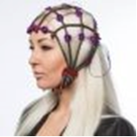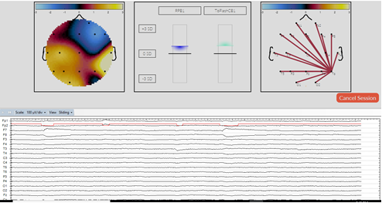

**Section IX - References**

Arns, M et al. (2014). Evaluation of neurofeedback in ADHD: The long and winding road, *Biological*

*Psychology*, 118, 108-115.

Bentum, K. W., & Aaron, P. G. (2003). Does reading instruction in learning disability resource

rooms real work?: A longitudinal study. *Reading Psychology*, 24, 361-382.

<http://dx.doi.org/10.1080/02702710390227387>

Burkett, S. V., Cummins, J. M., Dickson, R., & Skolnick, M. H. (2005). An open clinical trial utilizing

real-time EEG operant conditioning as adjunctive therapy in the treatment of crack cocaine dependence. *Journal of Neurotherapy*, 9(2), 27–47.

Coben, R., Wright, E. K., Decker, S. L., Morgan, T. (2015). The impact of coherence neurofeedback on

reading delays in learning disabled children: A randomized controlled study. *Neuroregulation*, Vol. 2 (4), 168-178. http://dx.doi.org.10.15540/nr.2.4.168

Eden, G. F., &Zeffiro, T. A. (1998). Neural systems affected in developmental dyslexia revealed by

functional neuroimaging, *Neuron*, 21 (2), 279-282. <http://dx.doi.org/10.1016/S0896-6273(00)>

80537-1

Forness, S. R. (2001). Special education and related services: What have we learned from meta-

analysis? *Exceptionality, 9*(4), 185-197.

http://adultaddstrengths.com/2011/01/12/adhd-and-crime-ignore-now-jail-later-15-clinical-studies/

https://www.scientificamerican.com/article/traumatic-brain-injury-prison/

Lindamood-Bell intervention program (2005) https://lindamoodbell.com/

Lindamood-Bell Learning Processes. (2005). Lindamood-Bell Learning Processes 2005 clinical

statistics. Retrieved from http://lindamoodbell.com/downloads/pdf/research/clinical%20stats%202005.pdf

Linden, M., et.al. A Controlled Study of the Effects of EEG biofeedback on Cognition and Behavior of

Children with Attention Deficit Disorder and Learning Disabilities. *Biofeedback and Self*

*Regulation*, Vol. 21, No. 1, 1996

McCandliss, B. D., & Noble, K.G. (2003). The development of reading impairment: a cognitive

neuroscience model, *Mental Retardation and Developmental Disabilities Research Reviews*, 9

(3), 196-205. Http://dx.doi.org/10.1002/mrdd.10080

Othmer, S., & Othmer, S.F. (1992), EEG Biofeedback Training for Hyperactivity, Attention Deficit

Disorder, Specific Learning Disability, and other Disorders, Handout EEG Spectrum, 16100

Ventura Blvd., Ste 100, Encino, Ca.

Ramus. F. (2004). Neurobiology of dyslexia: A reinterpretation of the data. *Trends in Neuroscience*, 27

(12). 720-726. http://dx.doi.org/10/1016/j.tins.2004.10.004

Ritchey, K. D., & Goeke, J. L. (2006). Orton-Gillingham and Orton-Gillingham-based reading

Instruction: A review of the literature. *The Journal of Special Education*, 40(3), 171-183.

Shaywitz, S. E., & Sharwitz. B.A. (2004). Reading disability and the brain. *Educational Leadership*, 61

(6), 6-11.

Slaughter, B., Fann, J. R., & Ehde, D. (2003). Traumatic brain injury in a county jail population:

Prevalence, neuropsychological functioning, and psychiatric disorders. *Brain Injury*, 17 (9),

731-741 <http://www.brainline.org/content/2009/05/traumatic-brain-injury-in-prisons-a->

review_pageall.html

Strong, G. K., Torgerson, C. J., Torgerson, D., & Hume, C. (2011). A systematic meta-analytic review

Of evidence for the effectiveness of the "Fast ForWord" language intervention program.

*Journal of Child Psychology and Psychiatry*, 52 (3),224-235. http://dx.doi.org/10.1111/j..1469-7610.2010.02329.x

Tansey, M. Wechsler (1991). (WISC-R) Changes Following Treatment of Learning Disabilities Via

EEG Biofeedback Training in a Private Practice Setting. *Australian Journal of Psychology*, 43,

147-153.

Thompson, L. & Thompson, M. (1998), Neurofeedback combined with training in meta-cognitive

Strategies: Effectiveness in students with ADD. *Applied Psychophysiology and Biofeedback*, 23

(4), 243-263.

Thornton, K. (2006). NCLB Goals (and more) are attainable with Neurocognitive Interventions, Vol. 1,

Booksurge Press

Thornton, K. & Carmody, D. (2013). The Relation between Memory improvement and QEEG changes

in three clinical groups as a result of EEG biofeedback treatment, *Journal of Neurotherapy*,

17(2). 116-132.

Thornton, K. (2014). A QEEG activation methodology which obtains 100% accuracy in the

 Discrimination of traumatic brain injured from normal and does the learning disabled show the

brain injury pattern?, *Neuroregulation*, 1 (3-4), 209-217.

Thornton, K. (2018). Perspectives on Placebo: The Psychology of Neurofeedback, NeuroRegulation, 5

(4), 137-149.

U.S. Department of Education, Institute of Educational Sciences (IES), 20010 https://ies.ed.gov/

Washington Summit on Learning Disabilities, 1994

http://odpc.ucsf.edu/sites/odpc.ucsf.edu/files/pdf_docs/REVISEDforensicpsychSQ.pdf

What Works Clearing House https://ies.ed.gov/ncee/wwc/

Wilson, B. A., &O'Conner, J.R. (1995). Effectiveness of the Wilson Reading System used in public

School training. In C. McIntyre and J. Pickering (Eds.), *Clinical Studies of Multisensory*

*Structured Language Education* (pp. 247-254). Salem, Or: International Multisensory Structured

Language Education Council.

Winter, C. (1997) Learning Disabilities, Crime, Delinquency, and Special Education Placement.

Adolescence, P.451-462

Wood, F. (2002). Wilson literacy solutions: Evidence of effectiveness. (unpublished data compilation

Report). Oxford MA: Wilson Language training corp.

**Ψ Kirtley E. Thornton, Ph.D.**

**9635 Southern Pine Blvd., Ste. 105,Charlotte, NC, 28273-5558   
 Phone: 980-229-4962; NJ Lic. 35S100168200, NC Lic. 4294**   
**Web: Neuroeducation.co**

**Email: ket@chp-neurotherapy.com**

Education:

Ph.D. Clinical Psychology, New School for Social Research, Graduate Faculty Division,NY, NY,1980, offered Hiram Halle Valedictorian Scholarship

M.A. Psychology, New School for Social Research, NY, NY 1976

B.A. Oberlin College, Oberlin, Ohio, 1964

Current / Previous Professional Involvement:

Administrative Director, Neuroscience Center, 2013-present; Neuroeducation LLC (2017-present)

Administrative Director, Center for Health Psychology, 1985-2013

Professional Affiliations:

National Academy of Neuropsychology, Professional Status; qEEG Certification Board, Diplomate, QEEG Board of Directors member (1995-2020), Advisor (2020 to present); International Society for Neuronal Regulation, member

Published Research

Neuropsychology of Sex Offenders. Journal of Offender Rehabilitation. Jan. 1991

The Anatomy of The Lie: An Exploratory Investigation via the quantitative EEG. Journal ofnder Rehabilitation, 1995, 22 (3/4), 179-185.

On the Nature of Artifacting the qEEG. Journal of Neurotherapy, 1 (3), 1996, 31-40.

The Fig Technique and the Functional Structure of Memory in Head Injured and Normal Subjects.Journal of Neurotherapy, 2 (1), 1997, 23-43.

Exploratory Investigation into Mild Brain Injury and Discriminant Analysis with High FrequencyBands (32-64 Hz), Brain Injury, August, 1999, 477-488.

Exploratory Analysis: Mild Head Injury, Discriminant Analysis with High Frequency Bands (32-64 Hz) under Attentional Activation Conditions & Does Time Heal?. Journal of Neurotherapy, Feb., 2000, 3 (3/4) 1-10.   
Electrophysiology of Auditory Memory of Paragraphs. Journal of Neurotherapy, 2000, Vol 4(3), 45-73.   
Rehabilitation of Memory Functioning in Brain Injured Subjects with EEG Biofeedback. Journal of Head Trauma Rehabilitation, Dec., 2000, 15 (6), 1285-1296.

Rehabilitation of Memory functioning with EEG Biofeedback. Neurorehabilitation, 2002, Vol. 17 (1), 69-81.

Electrophysiology of Visual Memory for Korean Characters. Current Psychology, Spring 2002, Vol. 21, No. 1, 85-108. Electrophysiology of the reasons the brain damaged subject can't recall what they hear. Archives of Clinical Neuropsychology, 2003, 17, 1-17.

Electrophysiology (QEEG) of Effective Reading Memory: Towards a Generator/Activation Theory of theMind. Journal of Neurotherapy, 2002, 6(3), 3 7-66.

A Cost/Benefit Analysis of Different Intervention Models for the LD/Special Education Student, Biofeedback,, 2004, 9-13.

Thornton, K. & Carmody, D. (2005). EEG Biofeedback for Reading Disabilities and Traumatic Brain Injuries. Child

and Adolescent Psychiatric Clinics of North America, Jan., 137-162.

Subtype Analysis of Learning Disability by Quantitative Electroencephalography Patterns, Biofeedback,2006, 34 (3), 106-113.

The qEEG in the Lie Detection Problem; The Localization of Guilt, J. of Neurotherapy, 2006

Reading Disability from the Activation Database Point of View, Neuroconnections, May, 2007, 9- 11.

Thornton, K. & Carmody, D. (2008). Efficacy of Traumatic Brain Injury Rehabilitation: Interventions of QEEG-Guided Biofeedback, Computers, Strategies, and Medications, Applied Psychophysiology and Biofeedback, (33) 2, 101-124.

Thornton, K. & Carmody, D. (2009). Eyes-Closed and Activation QEEG Databases in predicting

Cognitive Effectiveness and the Inefficiency Hypothesis, Journal of Neurotherapy, (13) 1,1-22

Thornton, K. & Carmody, D. (2009). Traumatic Brain Injury Rehabilitation: QEEG Biofeedback Treatment Protocols, Applied Psychophysiology and Biofeedback, (34) 1, 59-68.

Thornton, K, Carroll, C. (2010). The Coordinated Allocation of Resource (CAR) Model Intervention forReading, Problems in two clinics, Neuroconnections, Fall, 8-16.

Thornton, K.E. & Carmody, D.P. (2012). Symbol Digit and the Quantitative EEG, Journal of Neurotherapy,16:3, 210-222.

Thornton, K. (2014). A QEEG activation methodology which obtains 100% accuracy in the discrimination oftraumatic brain injured from normal and does the learning disabled show the brain injury pattern?,

Neuroregulation, 1 (3-4), 209-217.

Thornton, K. & Carmody, D. (2013). The Relation between Memory improvement and QEEG changes in three

clinical groups as a result of EEG biofeedback treatment, Journal of Neurotherapy, 17(2). 116-132.

Thornton, K., Carmody, D., (2014). The Coordinated Allocation of Resource (CAR) Electrophysiological Patterns of Recalling Names of Faces in Children, Adolescents and Adults and the Central Processing Unit (CPU) of the Brain, Neuroregulation, 1(1), 87-104.

Thornton, K. (2016). Neurotherapy and Connectivity, Biofeedback. Volume 44, Issue 4, pp. 218-224

Thornton, K. (2018). Perspectives on Placebo: The Psychology of Neurofeedback, NeuroRegulation, 5 (4), 137-149.

Thornton, K. (2020). The Electrophysiology of Pronunciation of Nonsense Words, Submitted for publication 5/20

Thornton, K. (2020) Towards an electrophysiological signature of reading memory in children.

Submitted to Journal of Learning Disability, 8/20

Book Chapters

Thornton, K. (2004). Ch. 95, Cognitive Rehabilitation and Neuronal Plasticity, In Roberts, Yaeger, K. (eds). Evidence Based Practice Manual, 857- 881. Oxford University Press

Thornton, K. & Carmody, D. (2009). Chapter Title: Traumatic Brain Injury and the Role of the Quantitative EEG in the assessment and remediation of cognitive sequelae.in Roland A. Carlstedt PhD (ed). Integrative Clinical Psychology, Psychiatry and Behavioral Medicine: Perspectives, Practices and Research, 463-508. Springer Publishing Company, Dec 14, 2009 -912 pages

Thornton, K. (2013). Traumatic Brain Injury, the Quantitative EEG and EEG biofeedback, accepted for publication, AAPB publication

Thornton, K. (2013) Chapter Title: The Role of the quantitative EEG in the diagnosis and rehabilitation of the

traumatic brain injured patient, Concussions in Athletics: From Brain to Behavior, Chapter 18, 463-5083, Eds. Semyon M. Slobounov and Wayne Sebastianelli, Springer publ., NY, NY

Thornton, K., Carmody, D., (2015). The Electrophysiological Coordinated Allocation of Resource (CAR) Model of Effective Reading in Children, Adolescents and Adults, T.F. Collura & J. Frederick, (Eds.) Clinician's Companion to QEEG and Neurofeedback. New York: Routledge

Book: NCLB Goals (and more) are attainable with Neurocognitive Interventions,Vol. 1, Booksurge Press, 2006

How the Cognitive Brain Works: The Quantitative EEG and Cognition, Create Space, 2016 (a compilatioon articles addressing the relationship between cognition and the QEEG)

Consultant: Traumatic Brain Injury Grant Reviewer: Department of Defense, 3/2012; 12/2008; Federal Grant Reviewer, May, 2009

Certification:

Licensed Psychologist, State of N.J. (#35 S1 00168200), North Carolina#4294   
Patents

QEEG Correlates of Effective Cognitive Functioning (memory and problem solving) in Diverse Clinical Conditions, patent issued 2/27/2018, #9,901,279 B2

Nominations:

1. 1998 Thomas A. Edison Patent of the Year Award

2. June, 2002 Award for Distinguished Professional Contributions to Independent or Institutional

Practice in the Private Sector

3. May, 2004 Award for Distinguished Contributions of Applications of Psychology to

Education and Training

4. 2004 New Abilities Foundation Award for Best New Freedom Product or Technology (considered by

supporters as the Nobel Peace prize award in the area of disabilities)

5. Aug., 2005 North American Brain Injury Society Innovations in Treatment Award

Awards:

Sept., 2009 Joseph Lubar Award for contributions to Neurotherapy, awarded by ISNR