CHART # 1
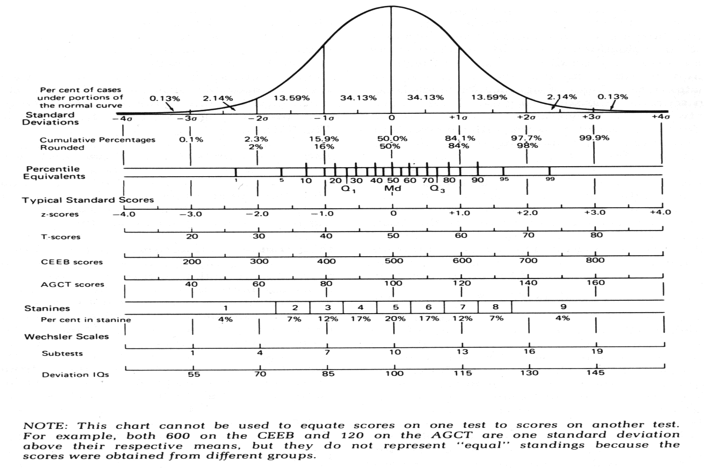

Conversion Table # 1
Label | IQ Scores | Z Score | T Score | % Rank
Highly Elevated | 146+ | 3.0+ | 81+ | 99+
Moderately to Highly | 139-145 | 2.5-3.0 | 76-80 | 99+
Moderately | 131-138 | 2.0-2.5 | 71-75 | 98-99
Mildly to Moderately | 123-130 | 1.5-2.0 | 66-70 | 91-97
Mildly Elevated | 116-122 | 1.0-1.5 | 61-65 | 81-90
Above Average | 108-115 | .50-1.0 | 55-60 | 67-80
Average | 93-107 | -.50 to +.50 | 45-54 | 30-66
Below Average Borderline | 85-92 | -1.0 to -.50 | 40-44 | 16-29
Mildly Impaired | 77-84 | -1.5 to -1.0 | 35-39 | 6-15
Mildly to Moderately | 70-76 | -2.0 to -1.5 | 30-34 | 2-5
Moderately | 63-69 | -2.5 to -2.0 | 25-29 | 1-2
Moderately-Severely | 55-62 | -3.0 to -2.5 | 20-24 | <1
Severe  <=under | <54 | -4.0 to -3.0 | 1-19 | <1

